Step 1: - Check the Http Server is installed or not in your system by running below command.

**WRKACTJOB SBS(QHTTPSVR)**

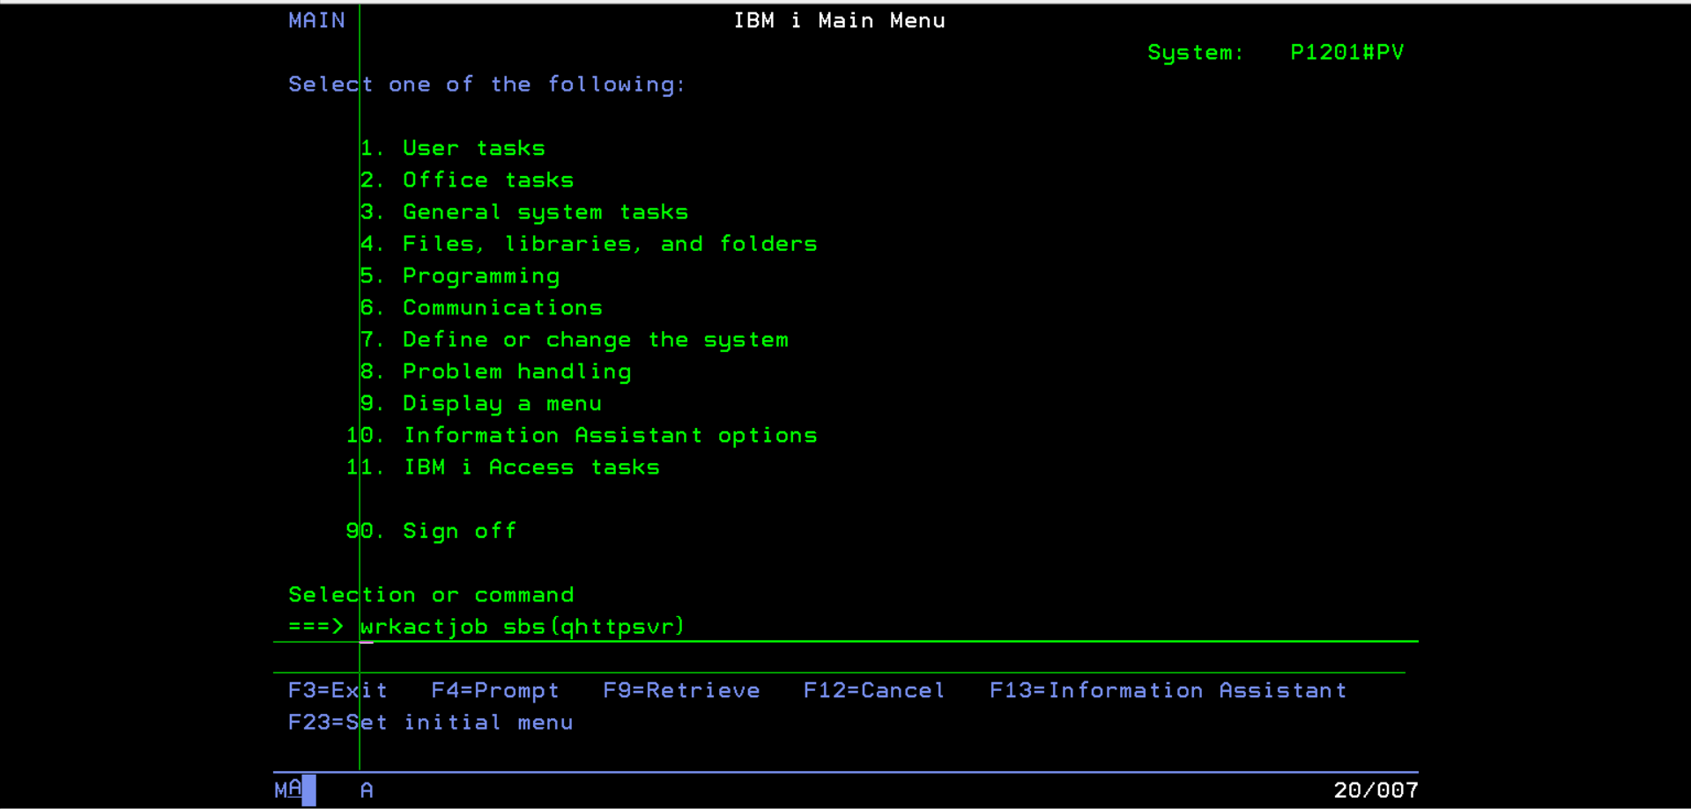

Step 2: - After running the above command you can see your Http Server subsystem if installed as shown below.

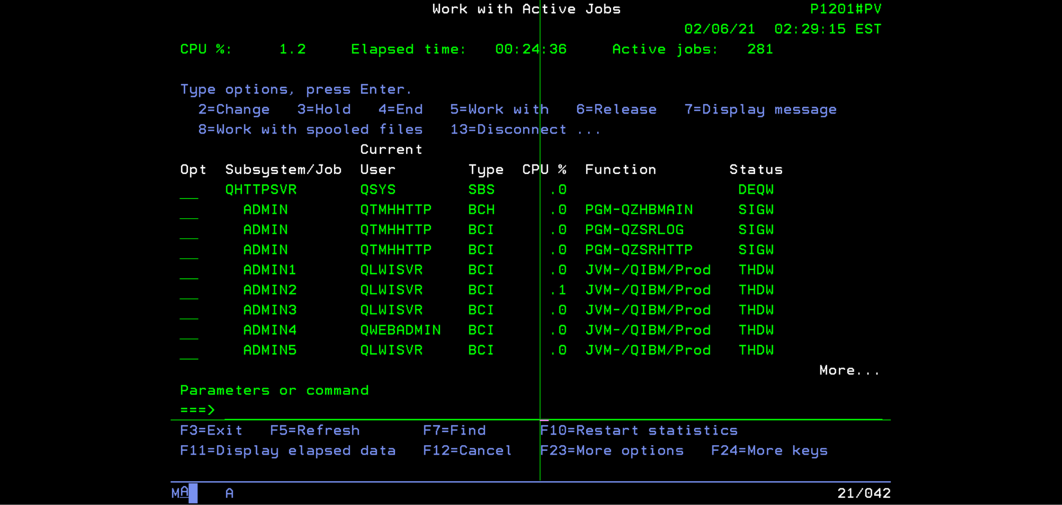

Step 3: - If not Http Server is not installed then run below command.

**STRTCPSVR *HTTP HTTPSVR(*ADMIN)**

Step 4: -Start the Apache server by running below command.

**STRTCPSVR SERVER(*HTTP) HTTPSVR(APACHEDFT)**

Step 5: - Go to Brower and enter your as400 IP/index.html in the URL and below page will appear.

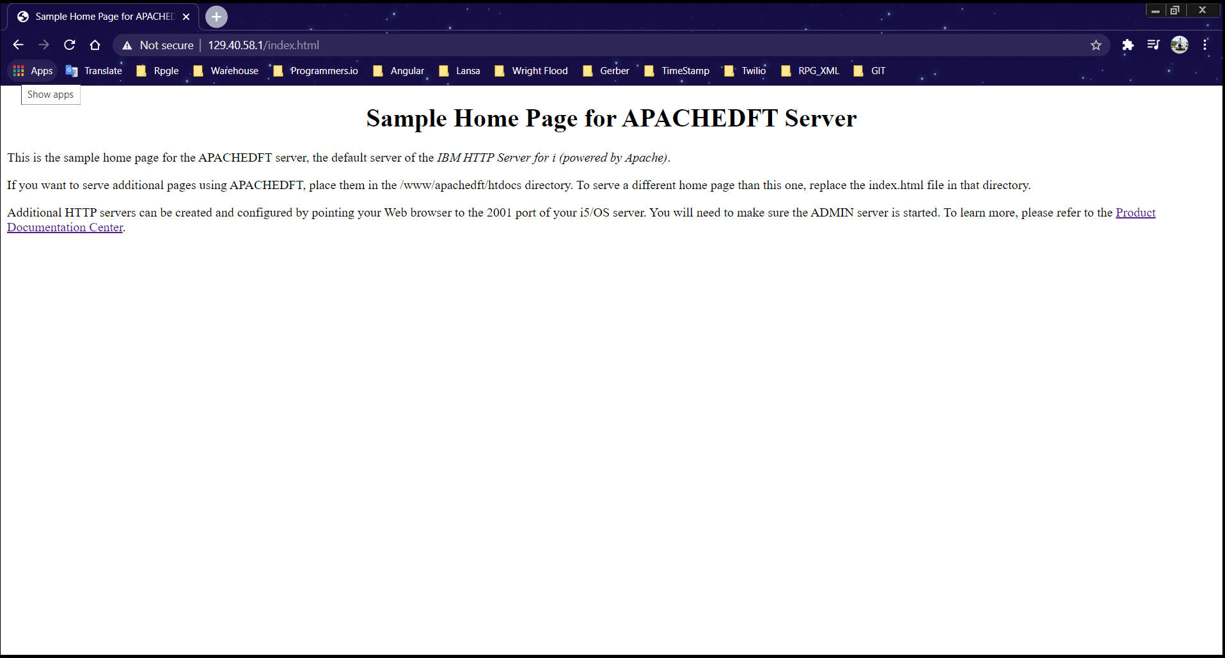

Step 6: - To create your own Web page, Open directory /www/apachedft/conf and your directory by using Alias as shown below.

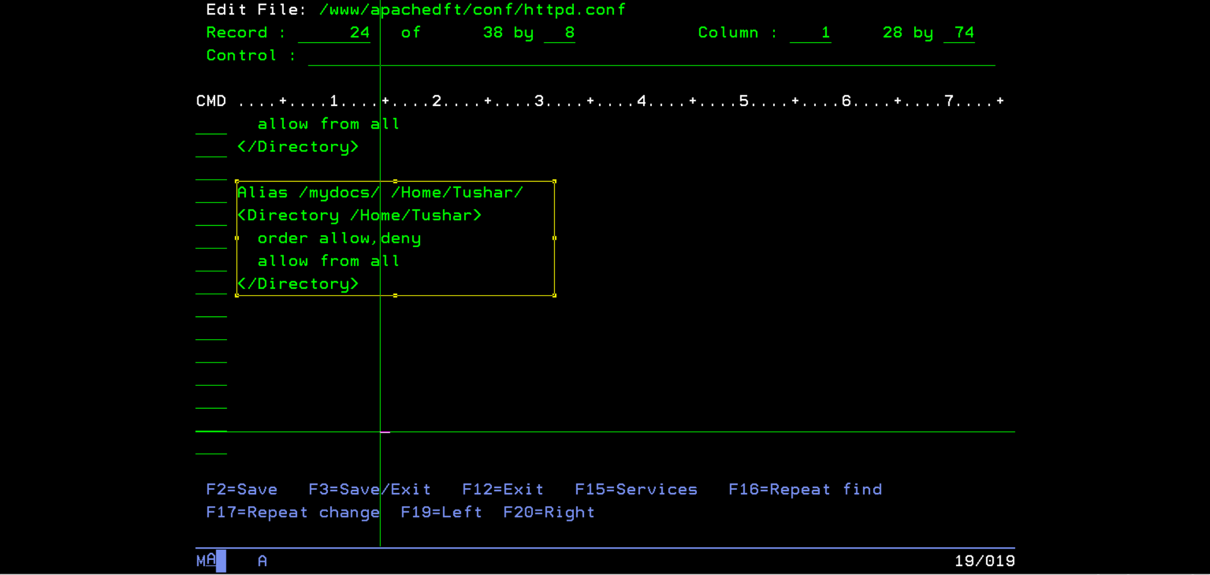

Step 7: - Restart the Apache Server by below command.

**STRTCPSVR SERVER(*HTTP) RESTART(*HTTP) HTTPSVR(APACHEDFT)**

Step 8: - Create new Directory in Home by using below command.

**CRTDIR DIR('Home/Tushar')**

Step 9: - Add the Html code in your Directory. Ex- Home/Tushar/Welcome.html.

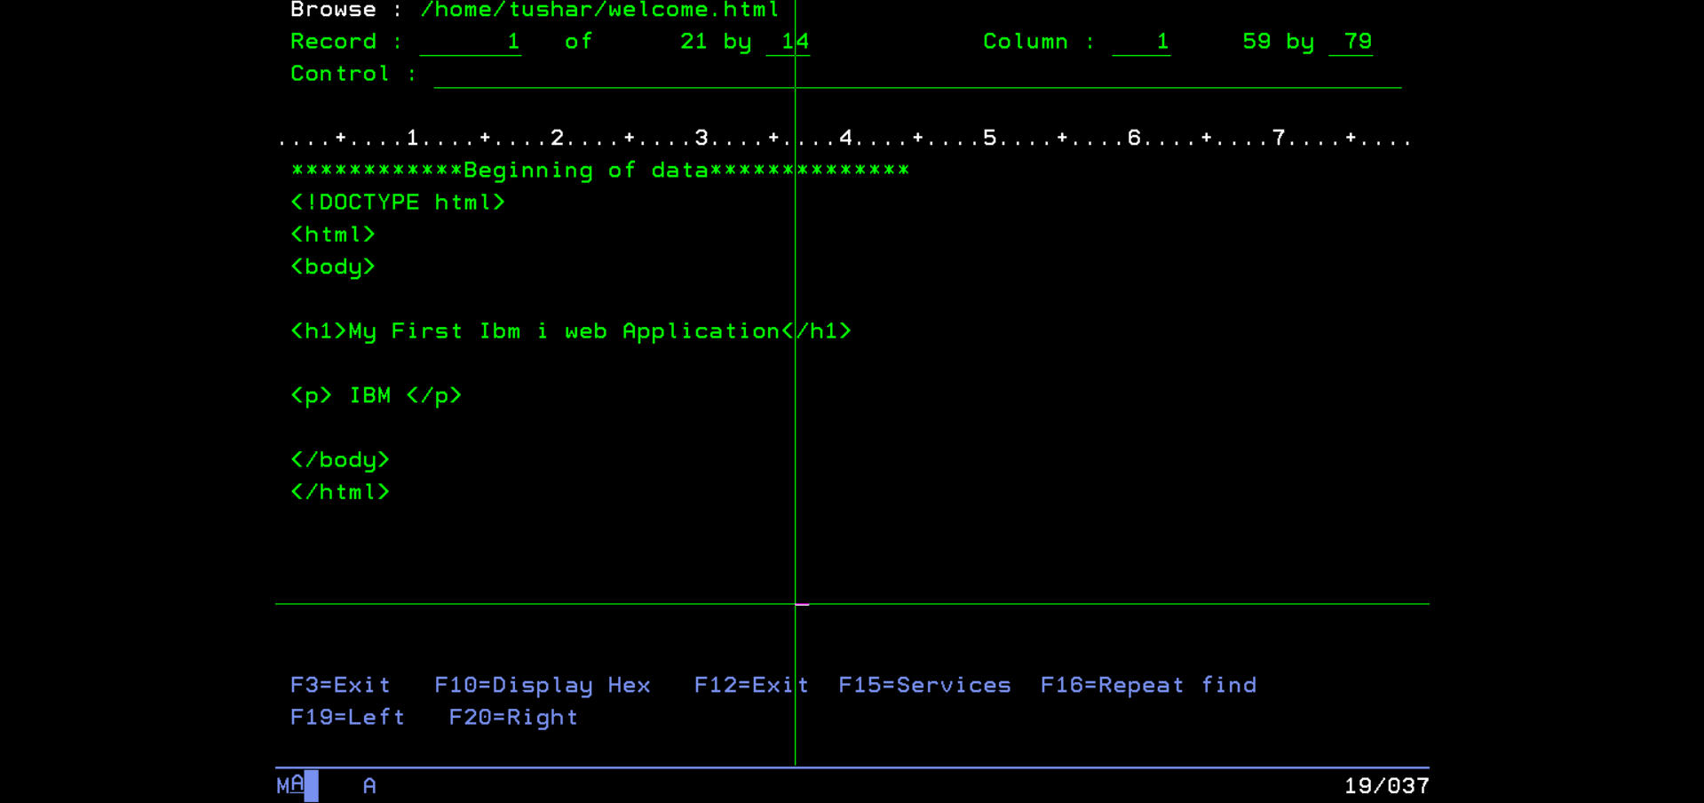

Step 10: - Go to Browser and enter your as400 IP/mydocs/welcome.html in the URL and your customize web page will appear as shown below.

